TITLE: MineARC Releases “EnviroLAV”, its newest product offering to the underground mining industry.
Six units purchased by Anglo American’s Grosvenor Coal Project

DATE: 15/11/2013
LOCATION: Perth, Australia
For Immediate Release.

MineARC Systems has released a newly engineered, intrinsically safe mine toilet system suitable for coal mines – the EnviroLAV Powerless.
Unlike standard electrical toilet systems, the powerless EnviroLAV system is designed to suit the volatile underground coal environment. The intrinsically safe design ensures no risk of electrical sparks and therefore no risk of explosion.
The Powerless EnviroLAV is a robust, self-contained, corrosion resistant steel toilet system that is simple to operate and maintain. The structure consists of latrine facilities mounted on top of a mini biological treatment plant, allowing waste matter to be deposited directly into the biological treatment process. Biogradeable, non-toxic EnviroZYME solution is placed directly into the toilet to treat the waste, eliminating the need for handling any hazardous chemicals.
MineARC has received its first order for this specially designed toilet system from Anglo American –for their Grosvenor coal project which is currently under construction in Moranbah. The EnviroLAV system was chosen because of its ultra-low maintenance design - allowing them to be moved underground easily and frequently, making them ideal for moving portals.
MineARC representative for Auxiliary Products James Young explains, “The EnviroLAV Powerless is a highly cost effective toilet when compared to other portable alternatives. It requires little maintenance and only needs to be emptied every 18-24 months unlike other conventional systems that require a 2-4 weekly drainage.”
For further information in regards to this product please contact James Young at james.young@minearc.com.au
MineARC Systems
For more info on this media release please contact Ben Johnson, Marketing Manager,
on: +61 (8) 9333 4966 or ben.johnson@minearc.com.au
END//
The EnviroLAV – external. 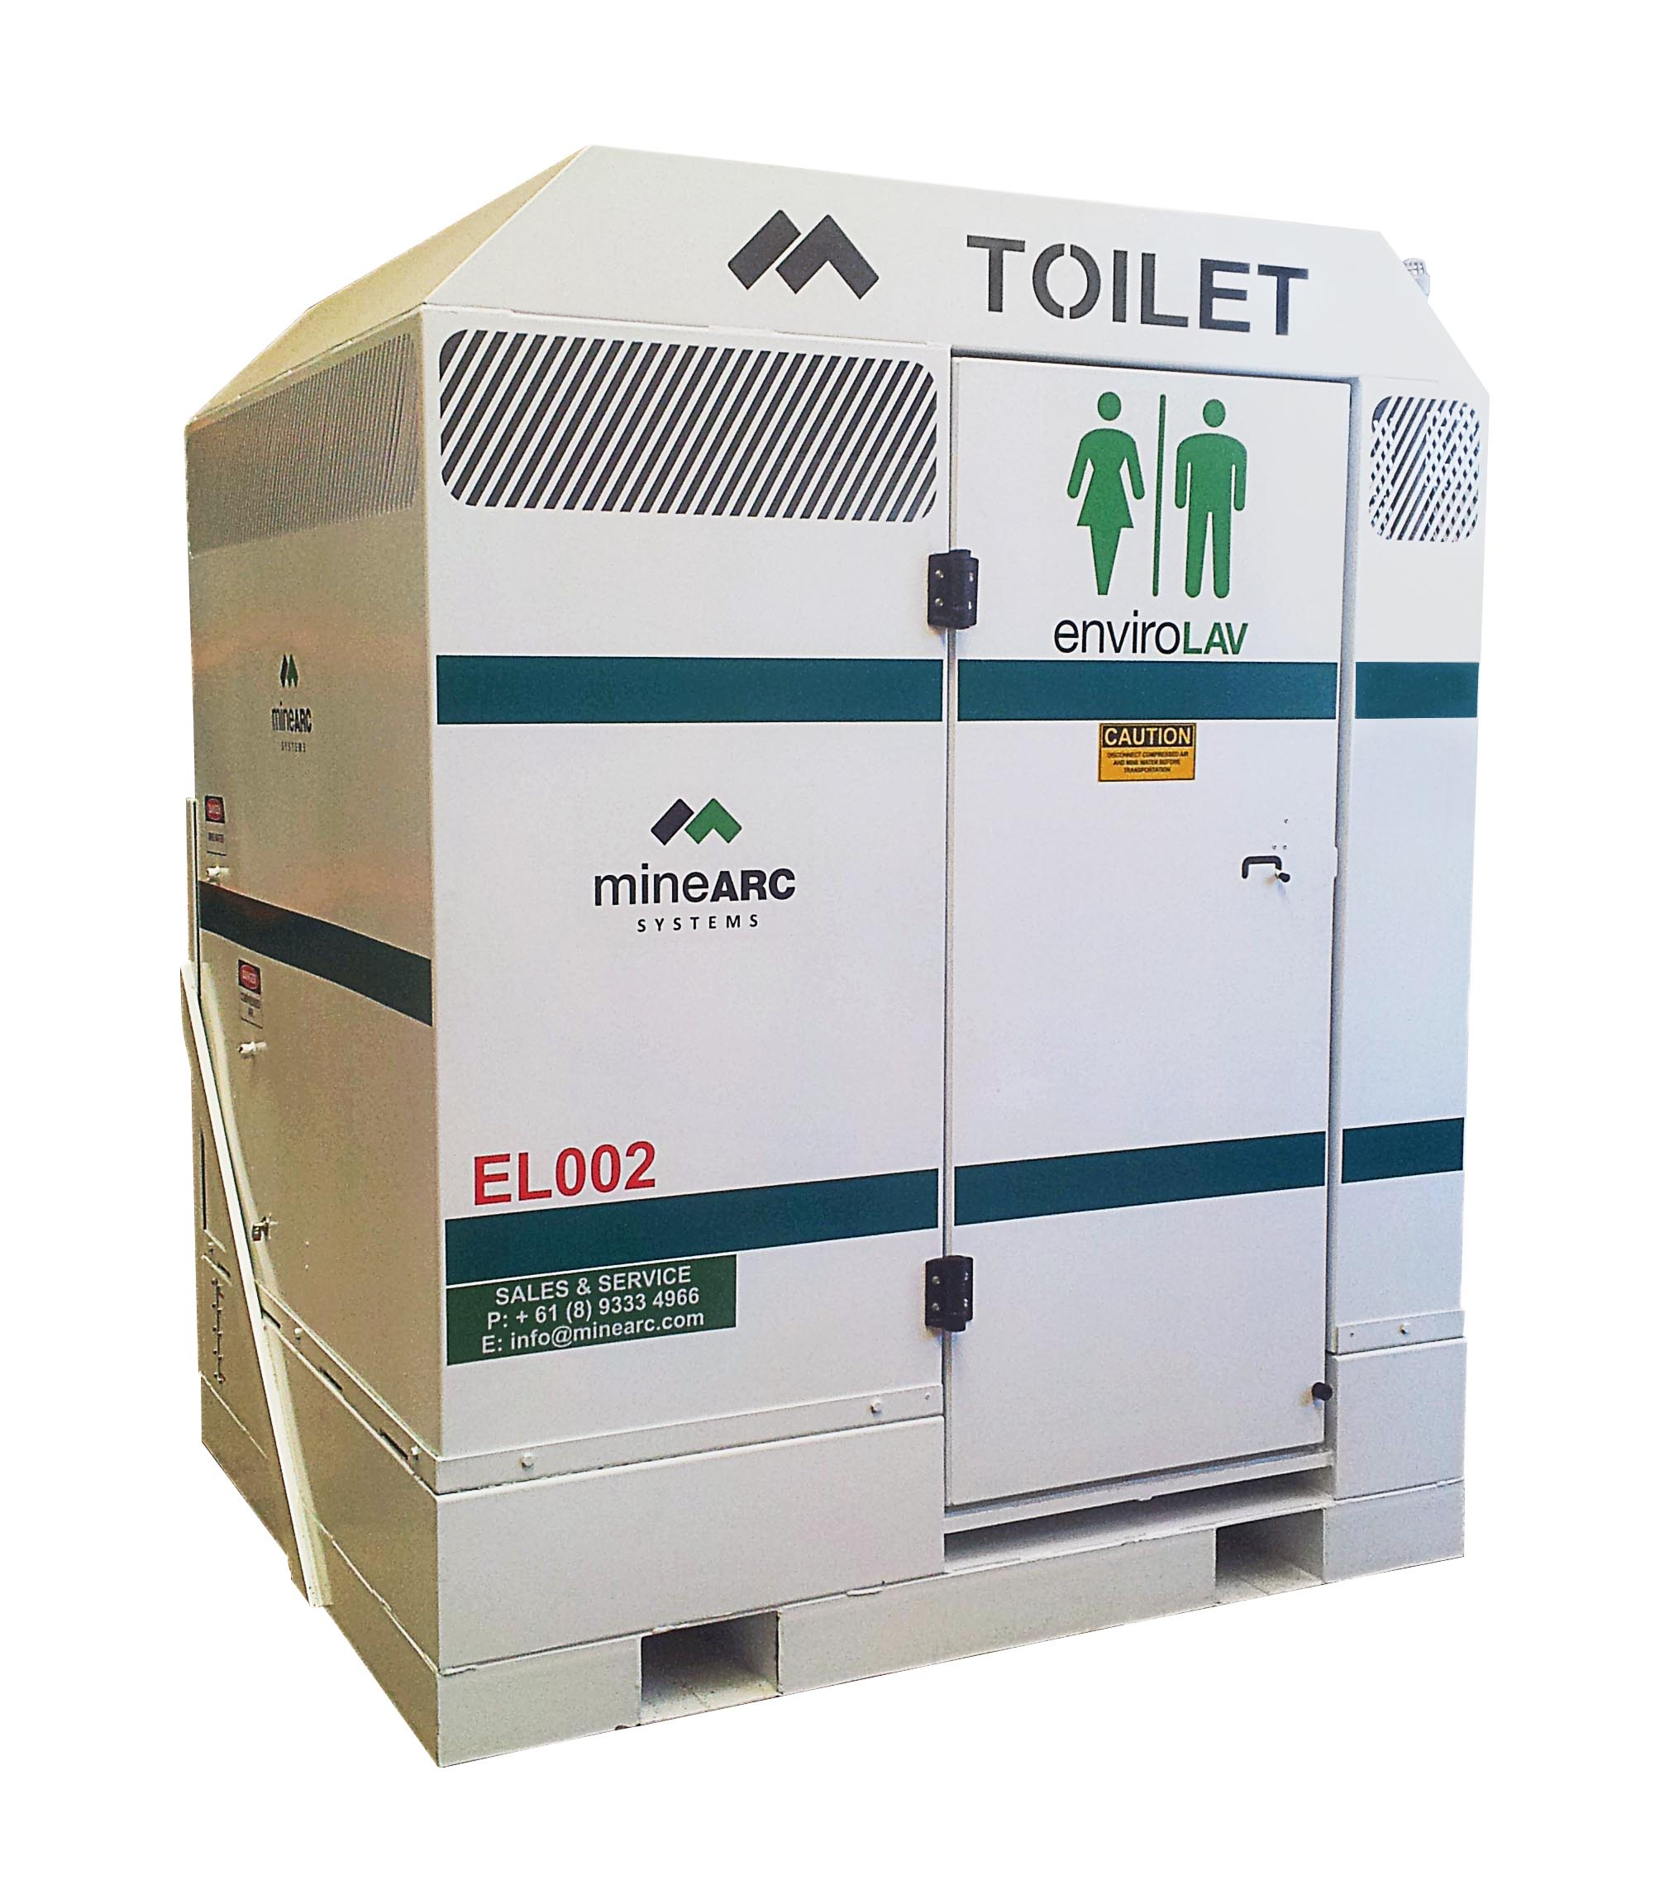

The EnviroLAV – internal.
